

|  |  |  |  |  |  |
| --- | --- | --- | --- | --- | --- |
| Programme | : | **M.Tech. (Integrated) Software Engineering** | Semester | : | **Fall 20-21** |
| Course | : | **Advanced Database Management Systems** | Code | : | **SWE2014** |
| Faculty | : | **Dr.Bhuvaneswari A** | Slot | : | **L27 + L28** |
| Date | : | **25-08-2020** | Marks | : | **10 Points** |

**NAME: K.NAVEEN KUMAR**

**REG: 17MIS1056**

Ex No. 6 Mendix Object Query Language

Experiment Online Link: <https://mydemoversion8-sandbox.mxapps.io/p/OQL>

Reference : <https://docs.mendix.com/refguide/oql>

**Given a Design of Enhanced Entity Relationship (EER) Model for Sales database. Write OQL for the following:**

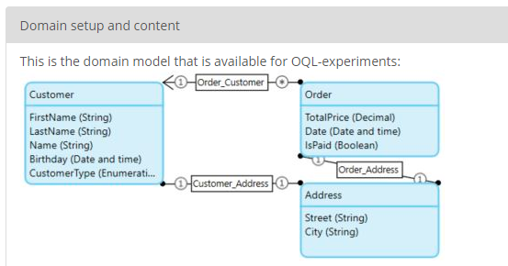

1. Add 10 New customers and add their address.

ANS:

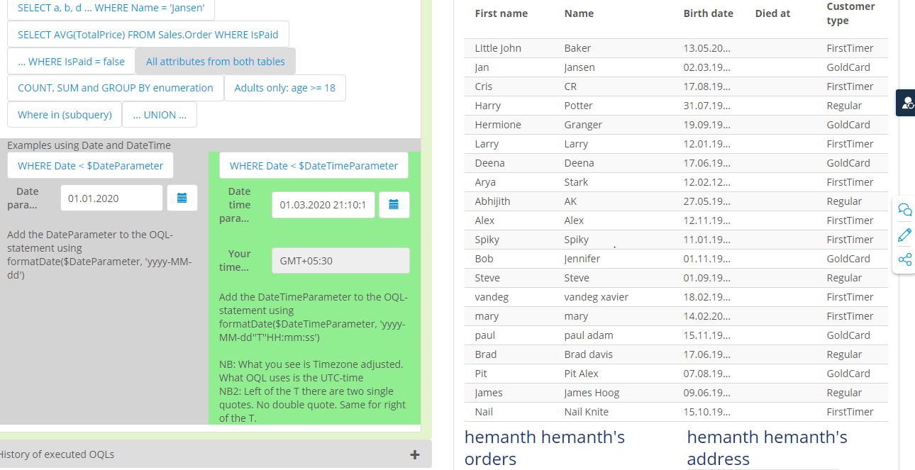

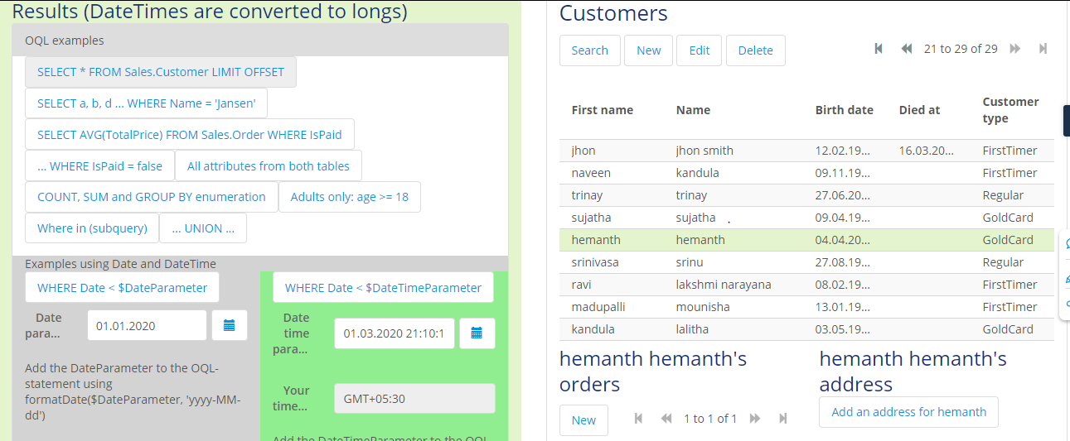

1. Add 10 New Orders by the existing customers.

ANS:

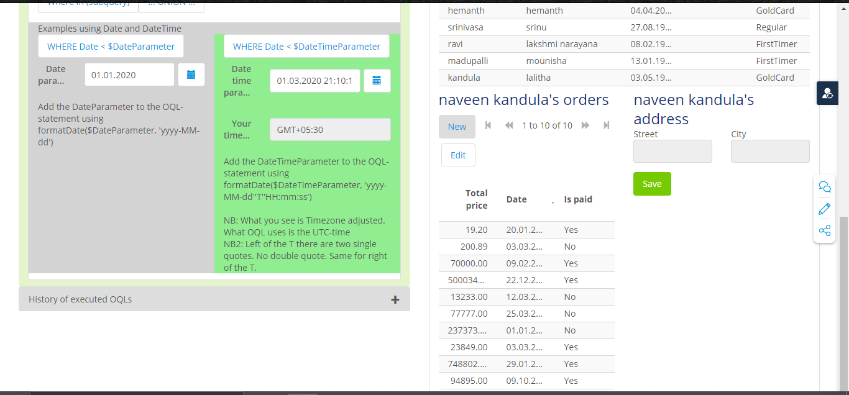

1. Write a QUERY statement that finds out each order number followed by the name of the customers who made the order.

ANS:

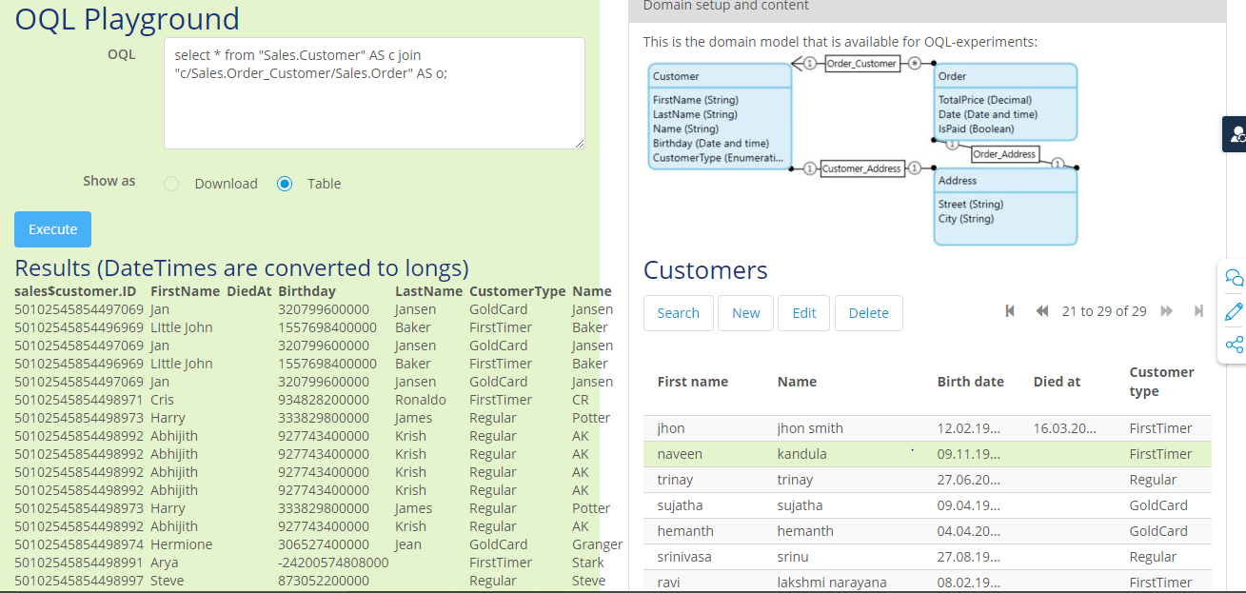

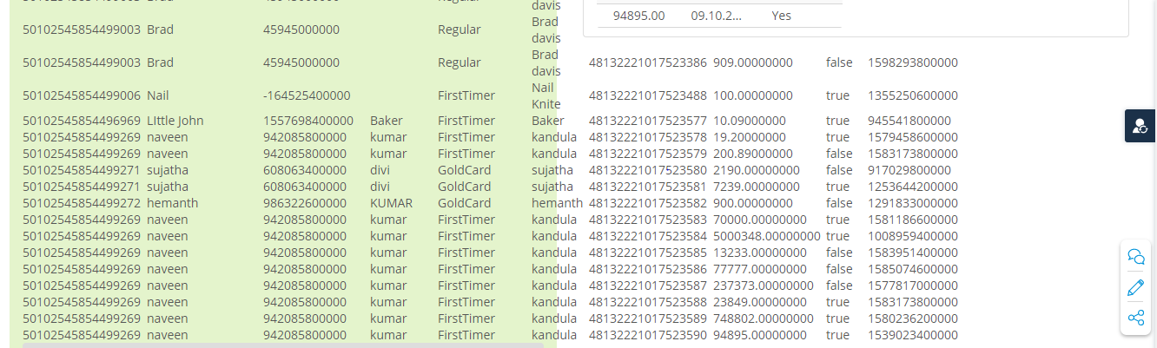

1. Write a QUERY to find the average total price of sales whose payment is success.

ANS:

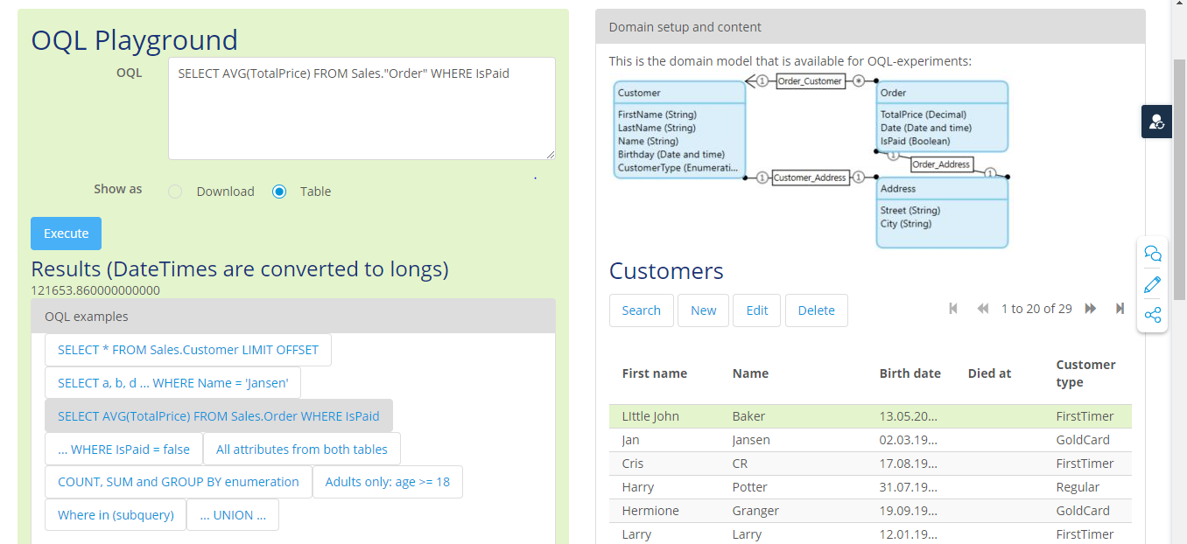

1. Write a QUERY to find the total orders placed by each customer type

ANS:

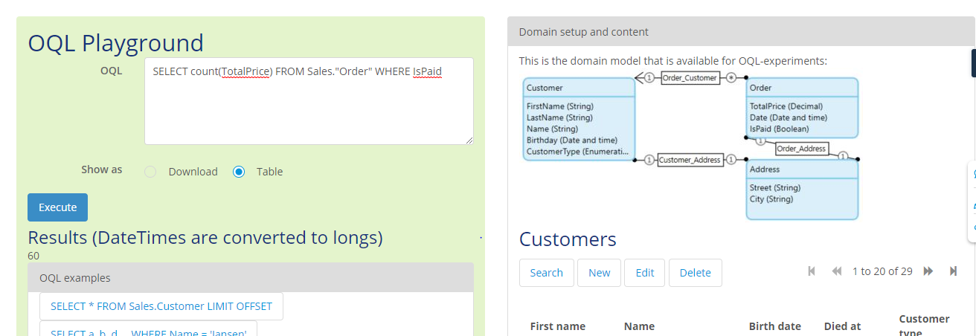

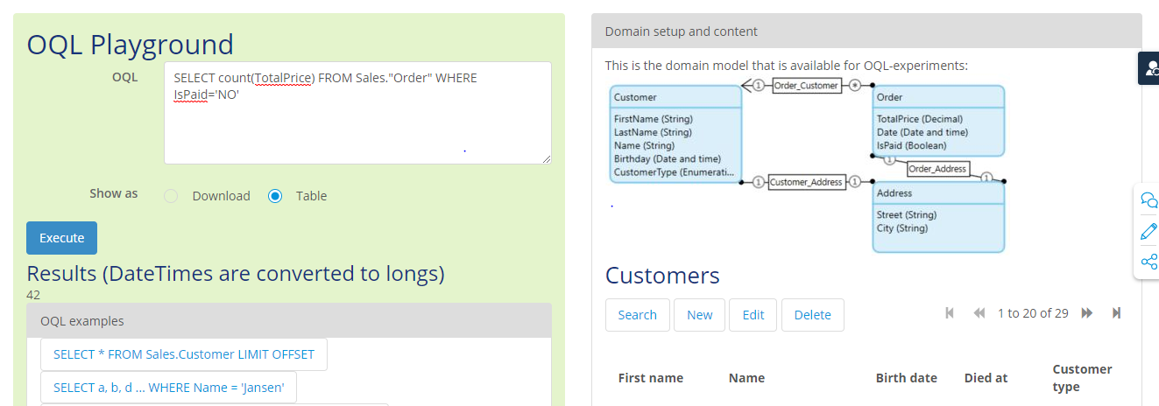

1. Write a QUERY to find the order details placed between Jan-2020 and Mar-2020 by each customer.

ANS:

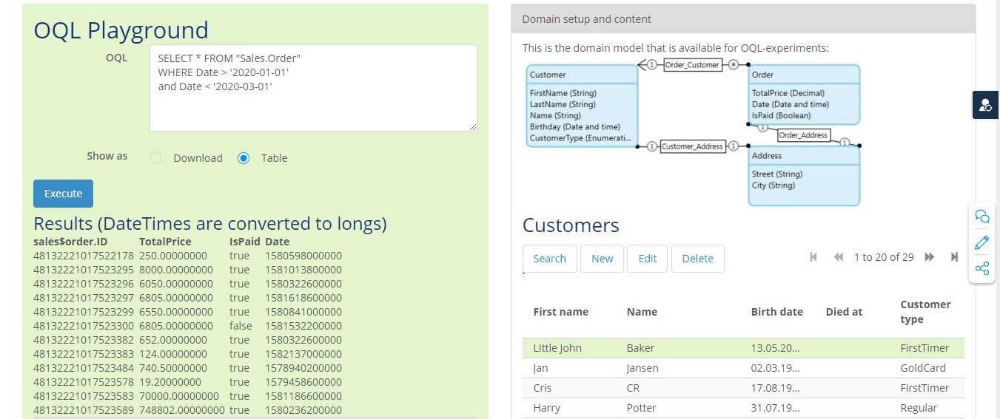

1. Write a QUERY to find the total amount paid by customer in 1999-2020.

ANS:

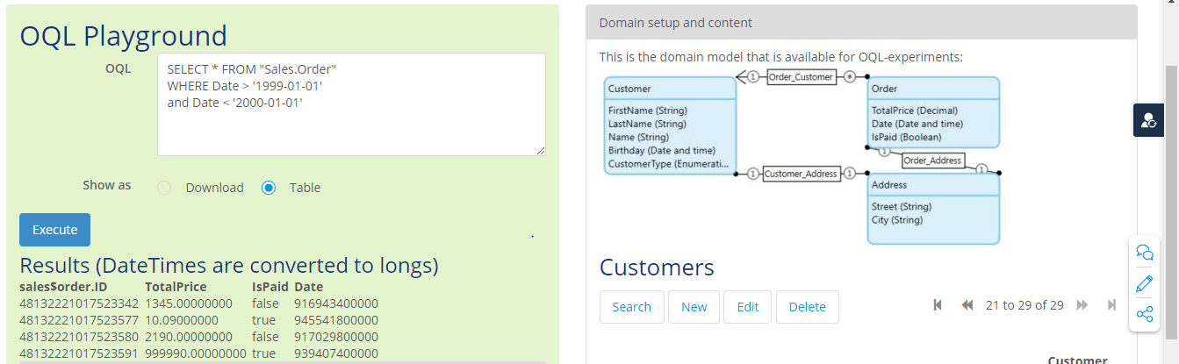

1. Write a QUERY to find customers address whose age is more than 35

ANS:

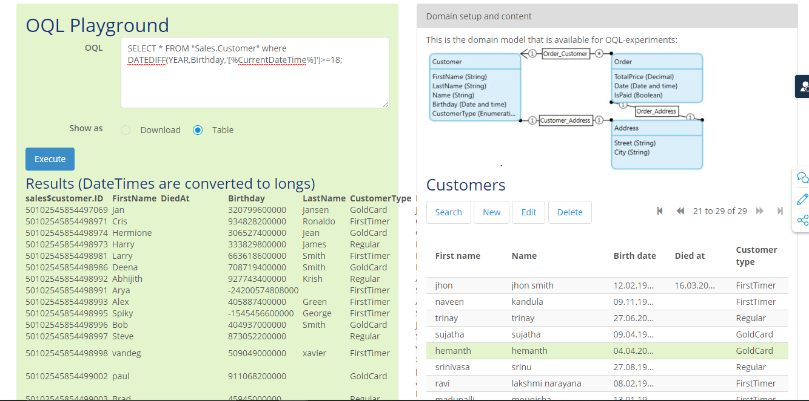

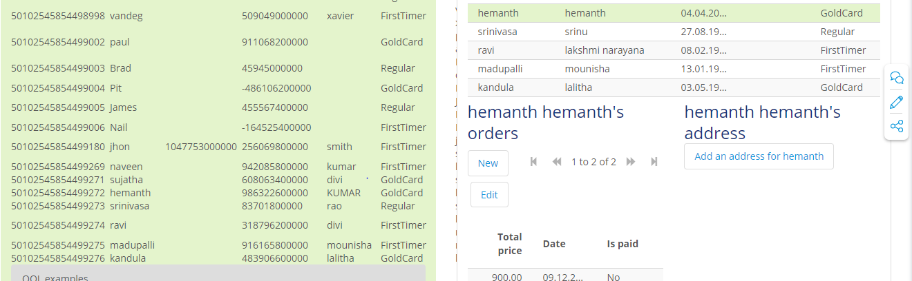

1. Write a QUERY to find top 3 customers in each type.

ANS:

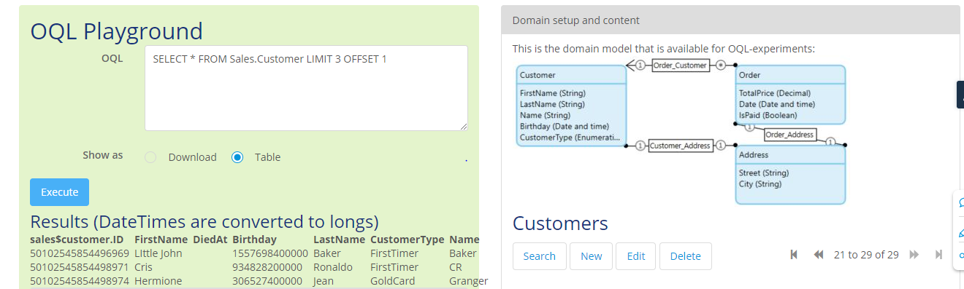

1. Delete randomly 3 orders

ANS:

